PROJECT DESIGN PHASE-II
Data Flow Diagram & User Stories – AI FAQ Assistant
Date | 27/09/2026
Team ID | SWTID-2026-9290
Project Name | AI FAQ Assistant
Maximum Marks | 4 Marks

Data Flow Diagram (DFD)
The DFD shows how data enters the AI FAQ Assistant, how the system processes the question, how the FAQ/knowledge base is accessed, and how the answer is returned to the user.

Components
- External Entity: User
- Process 1: Enter Question / Chat Interface
- Process 2: Process User Query
- Data Store: FAQ / Knowledge Base
- Process 3: AI Answer Generation / Retrieval
- Process 4: Display Answer & Feedback
- External Entity: Administrator
- Administrator flow: Add / Update / Delete FAQ data → FAQ / Knowledge Base

Suggested Level-0 Flow
User → Enter Question → Process Query → FAQ/Knowledge Base + AI Processing → Answer → User.
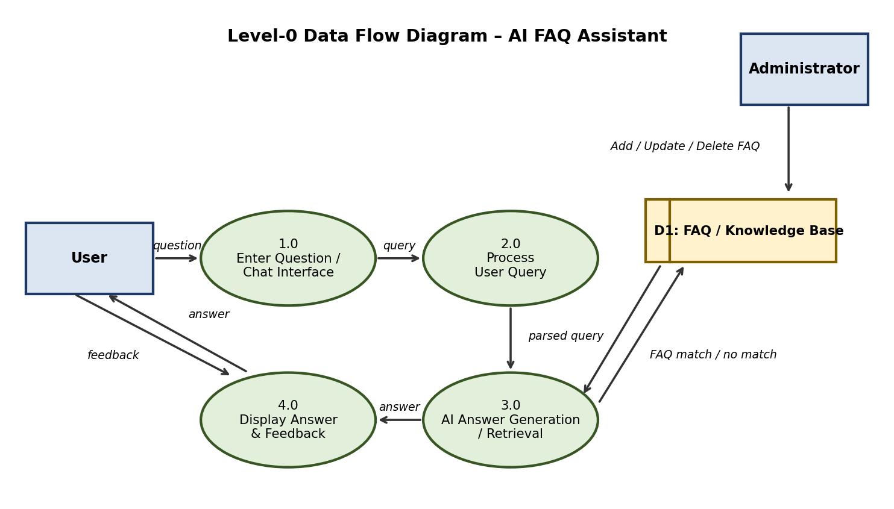
Figure 1: Level-0 Data Flow Diagram

User Stories
The following user stories are used in the project documentation.
User Type | User Requirement (Epic) | User Story No. | User Story / Task | Acceptance Criteria | Priority | Release
User | FAQ Query | USN-1 | As a user, I want to enter a question so that I can get an answer from the AI FAQ Assistant. | I can enter and submit a question. | High | Sprint-1
User | AI Response | USN-2 | As a user, I want the system to understand my question and provide a relevant answer. | A relevant answer is displayed for a supported question. | High | Sprint-1
User | Fallback | USN-3 | As a user, I want a clear message when my question is not available in the knowledge base. | A fallback message is shown and support/contact guidance is provided. | Medium | Sprint-2
User | Feedback | USN-4 | As a user, I want to give feedback on an answer so that the system can improve. | I can submit simple useful/not-useful feedback. | Medium | Sprint-2
Administrator | FAQ Management | USN-5 | As an administrator, I want to add, edit and delete FAQs so that the knowledge base stays updated. | Admin can successfully add, edit and delete FAQ records. | High | Sprint-2
Administrator | FAQ Review | USN-6 | As an administrator, I want to review FAQ content so that incorrect or outdated information can be corrected. | Admin can view and update existing FAQ content. | Medium | Sprint-2

